בס"ד

**דוגמאת הרצה:**

Insert the source code to the main folder

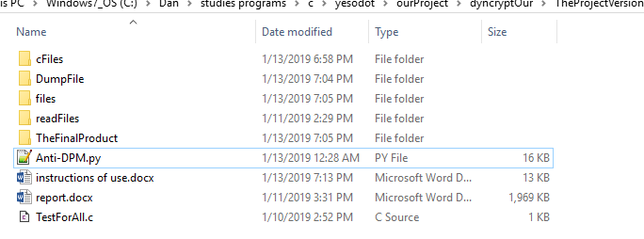

Enter the file name, please: TestForAll.c

Enter your key,please enter 16 digits and press enter:

1234123412341234

compile DumpTestForAll.c in DumpFile

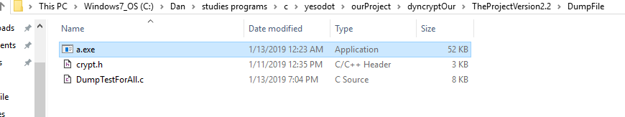

Insert the exe file to the main folder, please

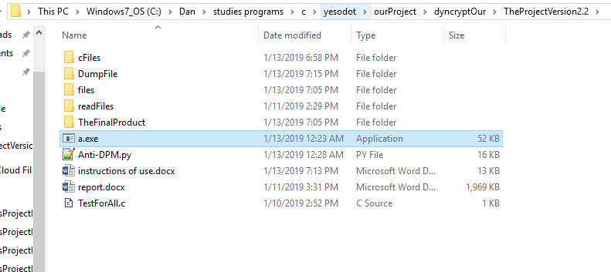

Enter the name of the exe: a.exe

wait a few seconds

the file: TestForAll.exe is ready in TheFinalProduct

